Functional Specification Documents

**Private College Social Network App**

1.0 Introduction

Imagine an innovative new app—a private social network designed specifically for colleges, with a strong focus on academic interactions. This platform aims to connect students and faculty members in an academic-oriented environment, creating an efficient way to seek and provide educational support. Here's a more detailed breakdown of what this app should include:

2.0 Wireframe Descriptions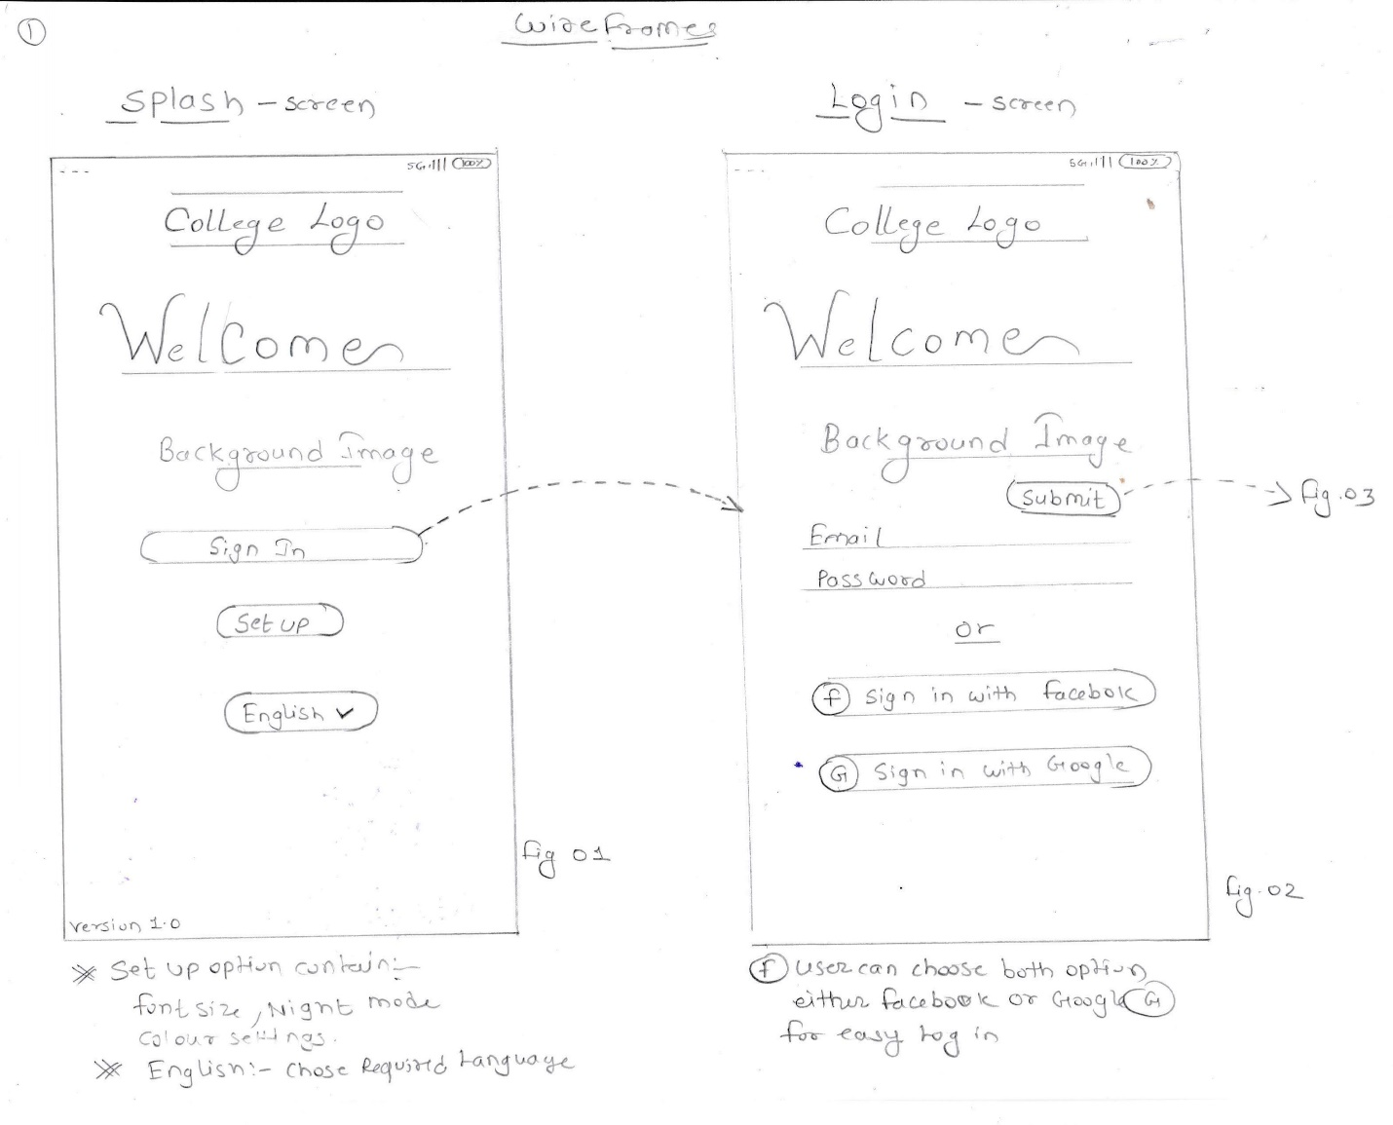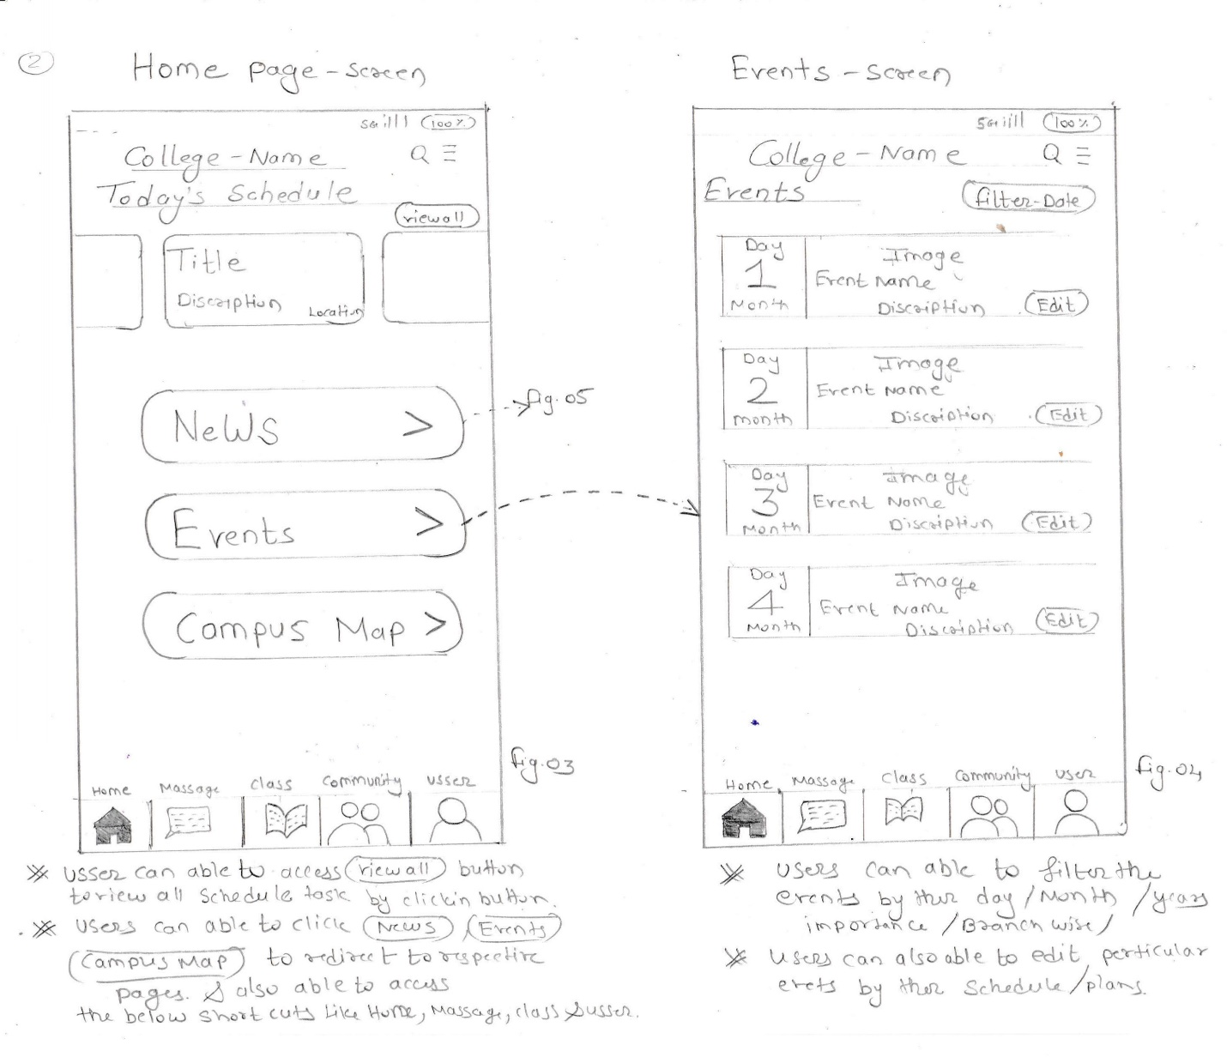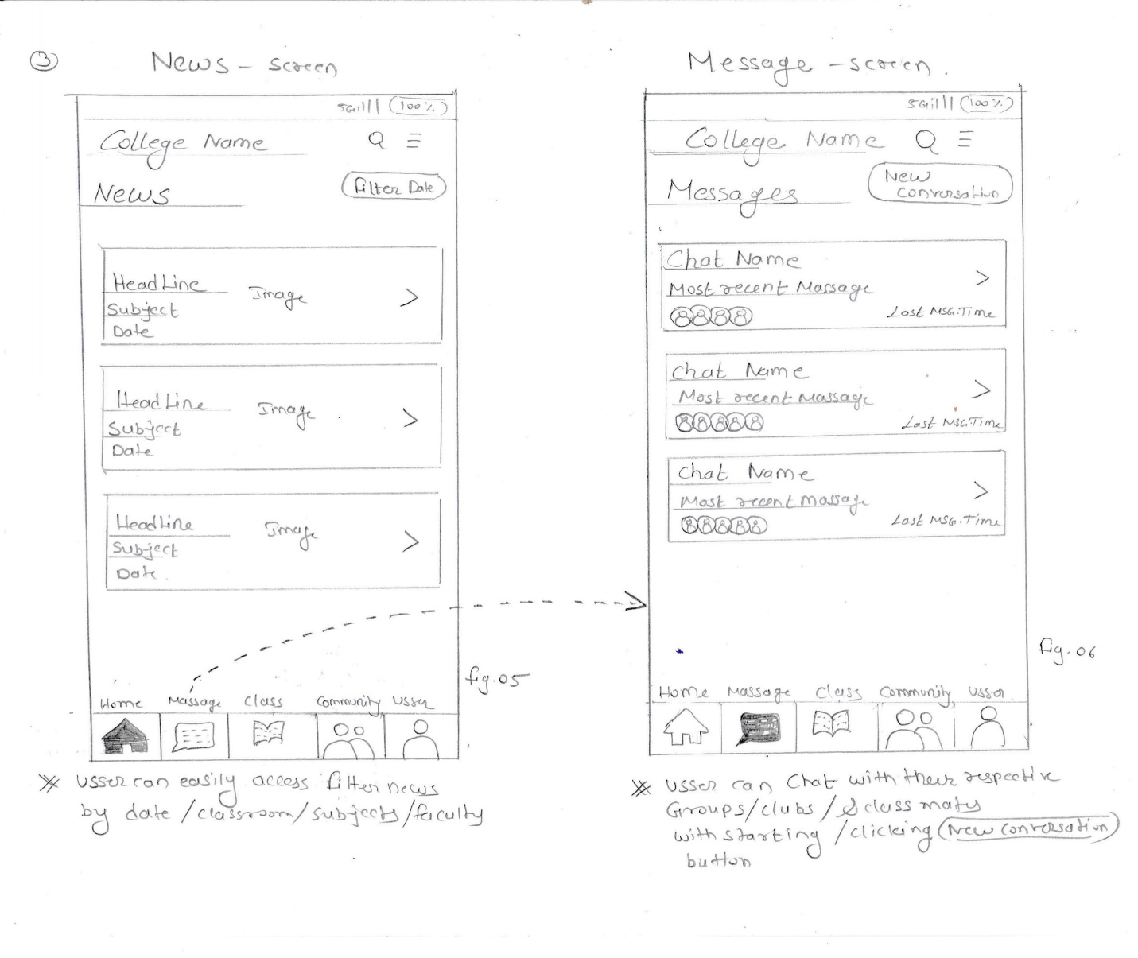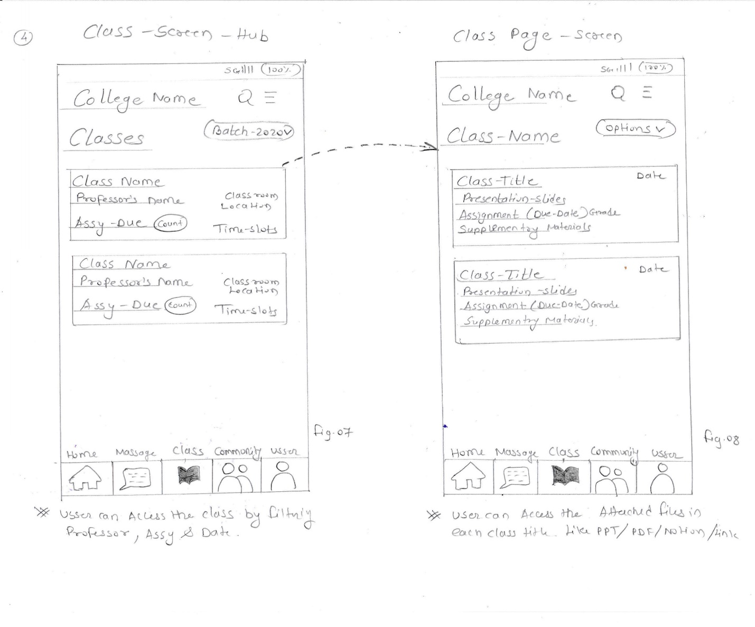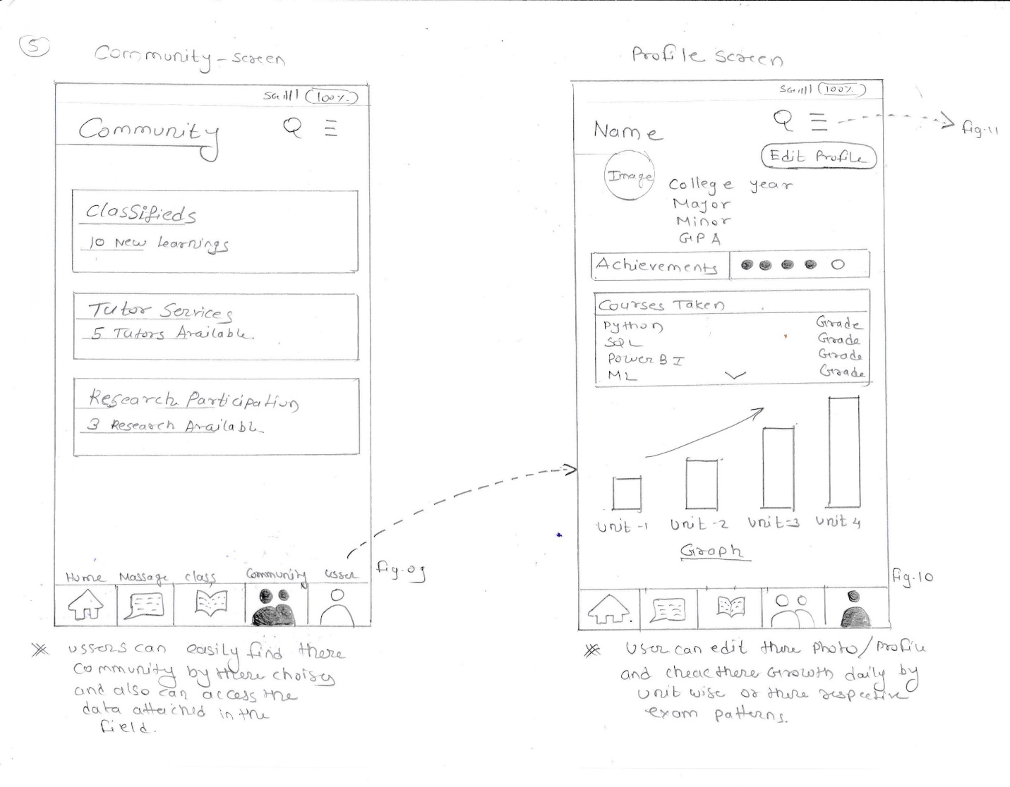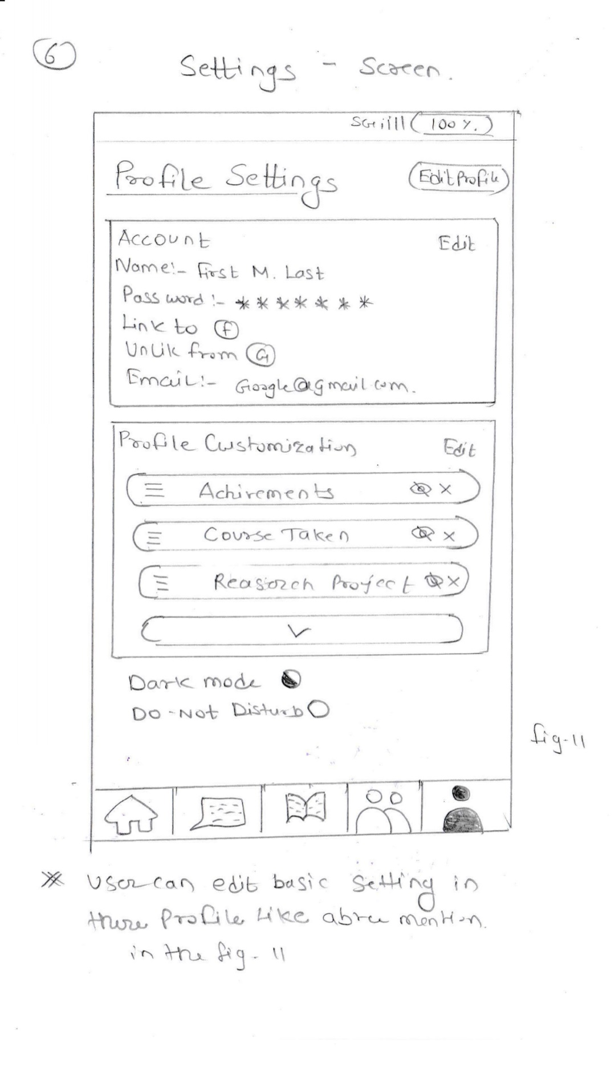

2.1 Splash Screen

As users launch the app, they'll be greeted with the college's logo and a warm welcome message.

In the background, an educational-themed image will set the tone.

Here, users will have the option to either sign in or proceed to set up their preferences.

Among the preferences is language selection, with all Indian languages available, and English as the default choice.

Additionally, users can customize their basic settings, including preferences like night mode and font size.

Once the login and preference setup is complete, users will be redirected to the app's home page.

2.2 Login Page

Continuing the warm and inviting theme, the login page features the college's logo and a friendly welcome message.

Here, users can sign in using their registered email and password.

To make the login process even more convenient, options for logging in through Facebook and Google accounts will be available.

2.3 Home Page

The home page reflects the familiar college logo and welcoming atmosphere.

In the top left corner, users will find a "Today’s Schedule" heading.

Beneath this, a box displays details of the day's schedule, including titles and descriptions.

Three essential buttons will be present: "News," "Events," and "Campus Map."

At the bottom of the home screen, users will discover shortcuts to various important pages, such as "Home," "Messages," "Classes," "Community," and a user icon.

Navigation should be seamless, allowing users to easily access options, perform searches, apply schedule filters, and check out the latest news, among other things.

Clicking on buttons and icons should quickly direct users to their intended destinations.

2.4 Event Page

In the event page, the college logo and educational background maintain the welcoming atmosphere.

The top left corner features the "Events" heading and a filter button for easy event exploration.

Below this, users will find a list of events displayed by day, date, and month.

Each event box contains background images relevant to the event, along with its name and description.

2.5 News Page

The news page carries the same welcoming visual theme, with the college's logo and educational background.

At the top left corner, there's a "News" heading.

Underneath the heading, users can browse through news items, presented in box format.

Each news box includes a headline, date, and related images.

2.6 Messages Page

On the messages page, the college logo and educational background maintain a consistent look and feel.

Under the "Messages" heading at the top left corner, recent chat names will be displayed.

Users can conveniently access the most recent chat, including images of the participants and the time of the last message.

2.7 Class Hub Page

The class hub page adheres to the visual identity with the college's logo and educational background.

In the top left corner, under the "Class Hub" heading, essential information about classes will be presented.

This information includes the class name, professor's name, pending assignments, and classroom locations.

2.8 Class Page

Just like the other screens, the class page will display the college's logo and educational background.

In the top left corner, under the "Class" heading, users will access details about their classes.

Here, users can find information such as the class title and access presentation slides.

2.9 Community Page

The community page adheres to the visual identity with the college's logo and educational background.

In the top left corner, under the "Community" heading, users will access details about various community elements.

These may include classified groups of people, experts, tutors, and research participation, fostering a sense of togetherness.

2.10 Profile Page

The profile page maintains the warm and inviting theme, displaying the college's logo and an educational background.

In the top left corner, users will access profile information under the "Profile" heading.

Profile details may include name, college year, major, minor, achievements, courses taken, and even a graphical representation of the student's progress.

2.11 Setting Page

The setting page is in line with the visual theme, displaying the college's logo and an educational background.

In the top left corner, under the "Settings" heading, users can access various profile settings.

Here, users can adjust account settings, update their name, manage login details, and personalize their profiles, ensuring a tailored experience.

These wireframe descriptions provide a clear overview of the app's interface, highlighting the content and functionality of each screen. Feel free to use this as a reference when creating more detailed mockups and specifications for your app. This is an exciting project that has the potential to enhance academic collaboration within colleges.

**Problem Statement for Design and Development Teams**

The Private College Social Network App aims to address several key issues that college students and faculty members encounter in their educational journey. By understanding these problems, our design and development teams can create a tailored solution that enhances the academic experience. Here's a summary of the problems we intend to solve:

**1. Lack of Efficient Academic Communication:**

Problem: Students and faculty members often struggle with efficient academic communication. Questions and doubts may go unanswered due to ineffective channels.

Solution: The app provides a platform where students can quickly seek help from peers or teachers. Guest faculties can also join conversations, ensuring that academic questions get timely answers.

**2. Fragmented Information Access:**

Problem: Relevant academic information is scattered across various sources, making it challenging for users to access it conveniently.

Solution: The app consolidates essential information, including class schedules, news, events, and community discussions, in one place. This reduces the need to navigate multiple platforms.

**3. Lack of Personalization:**

Problem: Users may struggle to customize their academic experience, leading to suboptimal usage.

Solution: The app offers personalization options, including language preferences, night mode, and font size settings, ensuring a tailored user experience.

**4. Inefficient Event Management:**

Problem: Students often miss out on college events and activities due to a lack of efficient event management tools.

Solution: The app's event management feature streamlines event information, allowing students to stay updated on campus activities.

**5. Disconnected Communication:**

Problem: Students and faculty members may find it challenging to engage in meaningful academic conversations.

Solution: The app fosters communication by bringing students, professors, and guest faculties together. This promotes knowledge sharing and collaborative learning.

**6. Academic Resource Scarcity:**

Problem: It can be challenging for students to access academic resources and materials effectively.

Solution: The app offers a hub for class-related materials, ensuring easy access to presentations and other resources.

**7. Fragmented News Access:**

Problem: Staying informed about college news can be cumbersome due to fragmented news sources.

Solution: The app centralizes college news, presenting headlines, dates, and relevant images for easy consumption.

**8. Inefficient Messaging:**

Problem: Users may struggle with efficient messaging and may miss important academic communications.

Solution: The app simplifies messaging by providing a chat system with quick access to recent chats and messages.

**9. Difficulty in Managing Classes:**

Problem: Students may find it challenging to manage their classes efficiently.

Solution: The app's class management feature helps students keep track of their classes, assignments, and classroom locations.

**10. Lack of Comprehensive User Profiles: -** Problem: User profiles may lack essential academic and personal information. - Solution: The app offers comprehensive user profiles, allowing students to showcase academic achievements, courses taken, and progress through graphical representations.

**11. Tedious Profile Setting Management: -** Problem: Users may find it challenging to manage their profile settings. - Solution: The app simplifies profile setting management, allowing users to customize their accounts, names, login details, and profile appearances.

By addressing these problems, the Private College Social Network App aims to create a seamless and efficient academic environment, enhancing the overall college experience for both students and faculty members. This information serves as a foundation for the design and development teams to ensure that the app's features and functionalities align with these problem-solving objectives.